| PROJECT INFORMATION | | | |
| --- | --- | --- | --- |
| **Report Description:** | Feature Extraction | | |
| **Professor:** | Prof. [Gady Agam](mailto:agam@iit.edu) | **Tools used/work done:** | 1. Augmentation 2. Feature Extraction and training |
| **Report prepared by:** | [Noviya Balasubramanian](mailto:nbalasubramanian@hawk.iit.edu) |
| **HAWK ID:** | A20541236 |
| **Report no:** | 13 | **Report Date:** | 11/8/2024 |

**Timeline:**

1. **First 6 Weeks: Literature Review, Data Access, Preprocessing, Problem Statement Definition**
2. **Week 7 (Oct 4): Data Preprocessing Completion, MARA Exploration in MATLAB - Completed for 33 subjects**
3. **Week 8 (Oct 11): Labeling, Feature Extraction and Classification - Initial Training**
4. **Week 9 (Oct 18): Classifier Selection and Initial Training - Feature extraction**
5. **Week 10 (Oct 25): Classifier Optimization and Validation - [**[**Worked in Augmentation**](https://colab.research.google.com/drive/1u_p-kIBw7xU9kgNdWy27XNOM-br_-Ia7?authuser=4#scrollTo=6rUZ1Dl13Heu)**]**
6. **Week 11 (Nov 1): ~~Multimodal Analysis~~ - Did CNN Classifier**
7. **Week 12 (Nov 8): Fusion or Comparison Analysis Scope**
8. **Week 13 (Nov 15): Final Testing**
9. Week 14 (Nov 22): Model Evaluation
10. Week 15 (Nov 29): Report Preparation (Buffer)
11. Week 16 (Dec 6): Report Submission

**Topic: Classification of Cognitive States Using EEG and Physiological Signals: Impasse, Aha!, Uncertainty**

- **Total Labels Loaded**: 910, 1s Window size

**Before Augmentation:** Total Segments: 910; Shape of Segments: (125, 16)

Total Labels: 910

Label Counts: Walking: 290; Aha: 290; Doing Other Task: 290; Re-evaluation: 25; Impasse: 15

Gaussian noise is added to the original segments, generating new samples that mimic the statistical properties of the existing data. This noise is produced using a normal distribution with a 0 mean and 0.01 standard deviation, ensuring the augmented data retains its underlying characteristics.

**After Augmentation:** Total Segments: 1450; Shape of Segments: (125, 16)

Total Labels: 1450

New Label Counts: Walking: 290; Aha: 290; Doing Other Task: 290; Impasse: 290; Re-evaluation: 290

>> Aha vs not - AHa

>> Impasse vs not - Impasse

>> Attention vs not

Added Standard deviation - 0.05

**My summary features Approach autoencoder - Fusion-based EEG:**

**raw - 1450 x 125 x 16  
Time - (1450 x** 64**)**

**CNN - (1450 x 3945)**

**Freq - (1450 x 160)**

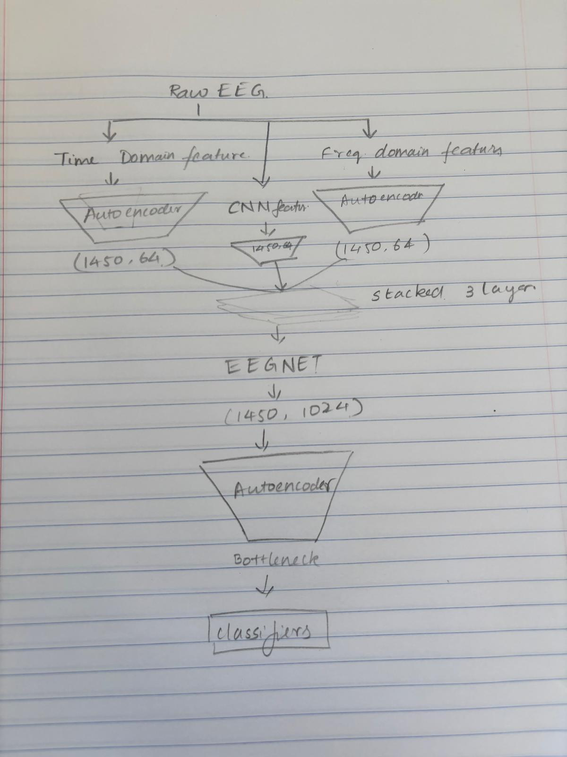

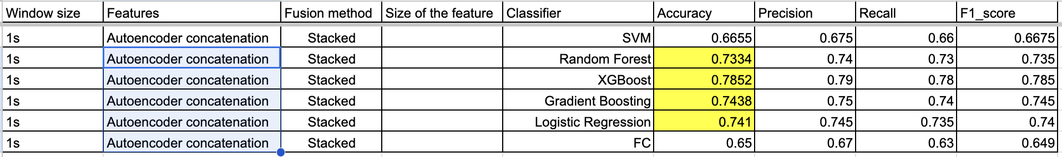

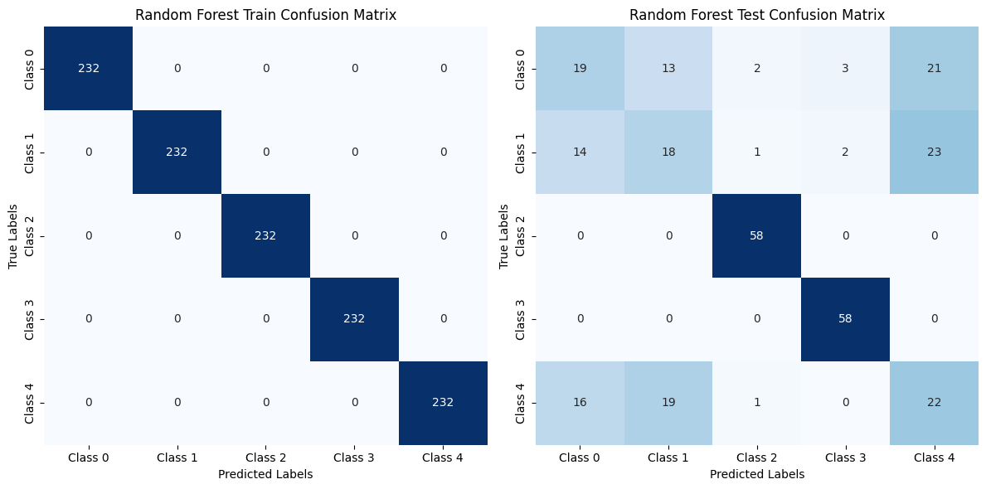

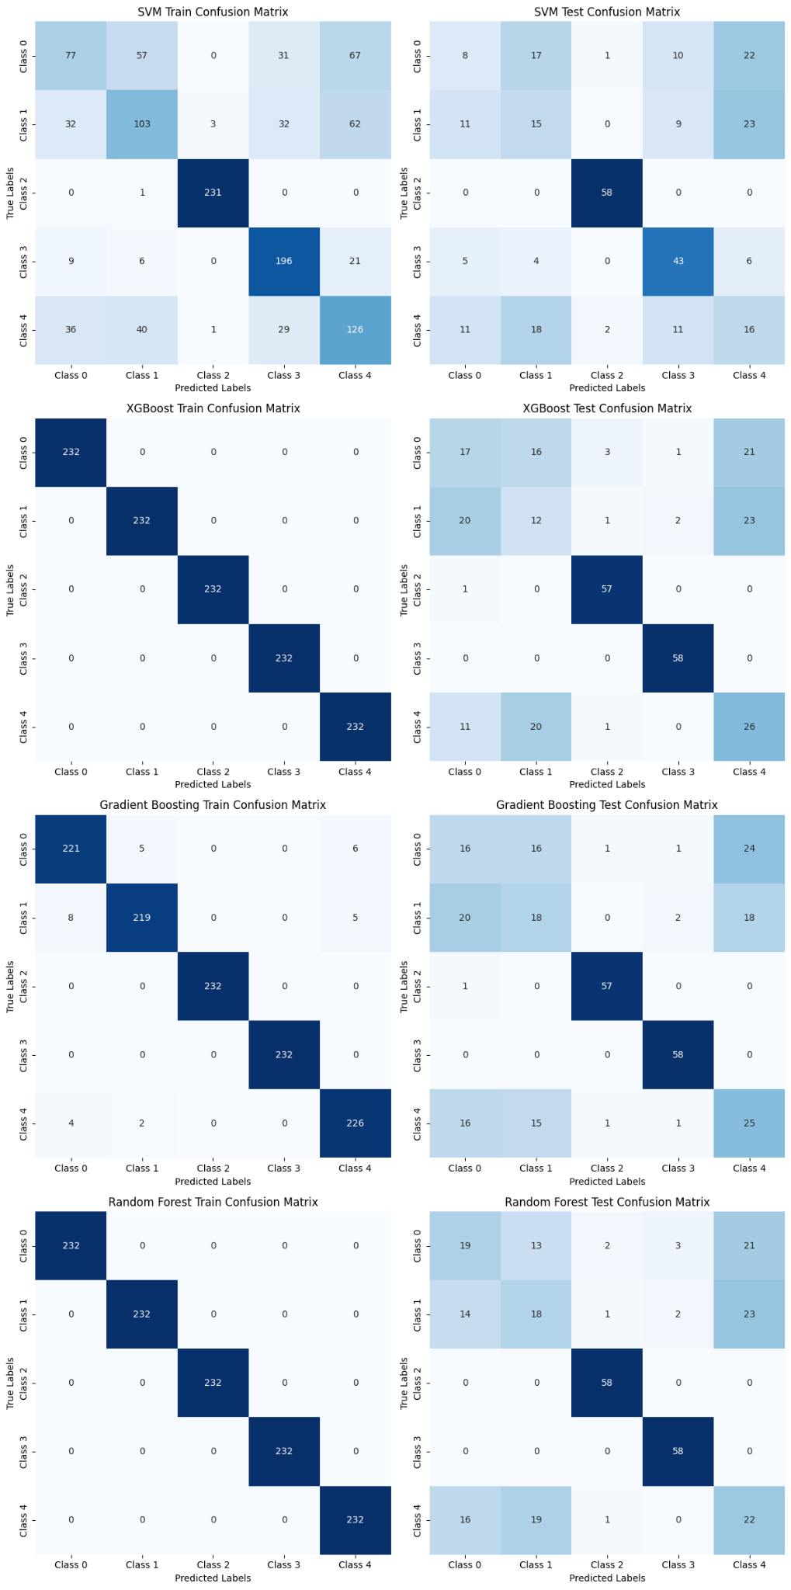

**[1]G. Jiang, K. Wang, Q. He and P. Xie, "E2FNet: An EEG- and EMG-Based Fusion Network for Hand Motion Intention Recognition," in IEEE Sensors Journal, vol. 24, no. 22, pp. 38417-38428, 15 Nov.15, 2024, doi: 10.1109/JSEN.2024.3471894.** <https://ieeexplore.ieee.org/document/10706790>

The paper’s approach focuses on utilizing a wavelet transform followed by LSTM layers to extract **temporal dynamics** of EEG signals. It emphasizes sequential feature extraction but does not explicitly include a separate spatial feature extraction pathway. Additionally, their work combines CNN-extracted features from EMG data with EEG features through a fusion method to enhance classification performance.

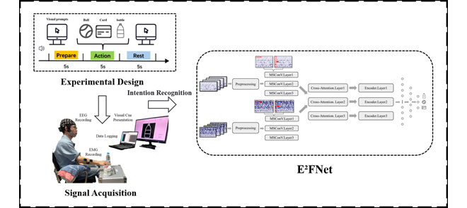

My approach **Spatio-Temporal FNet**:

In my approach, I developed a hybrid deep learning architecture, that integrates both **spatial** and **temporal feature extraction** pathways. The spatial features are captured using Convolutional Neural Networks (CNN) with batch normalization and pooling layers to process spatial relationships in the EEG data. Simultaneously, temporal features are extracted using Long Short-Term Memory (LSTM) layers, which focus on capturing the sequential dynamics of EEG signals. These pathways are fused to create a comprehensive feature representation before classification.

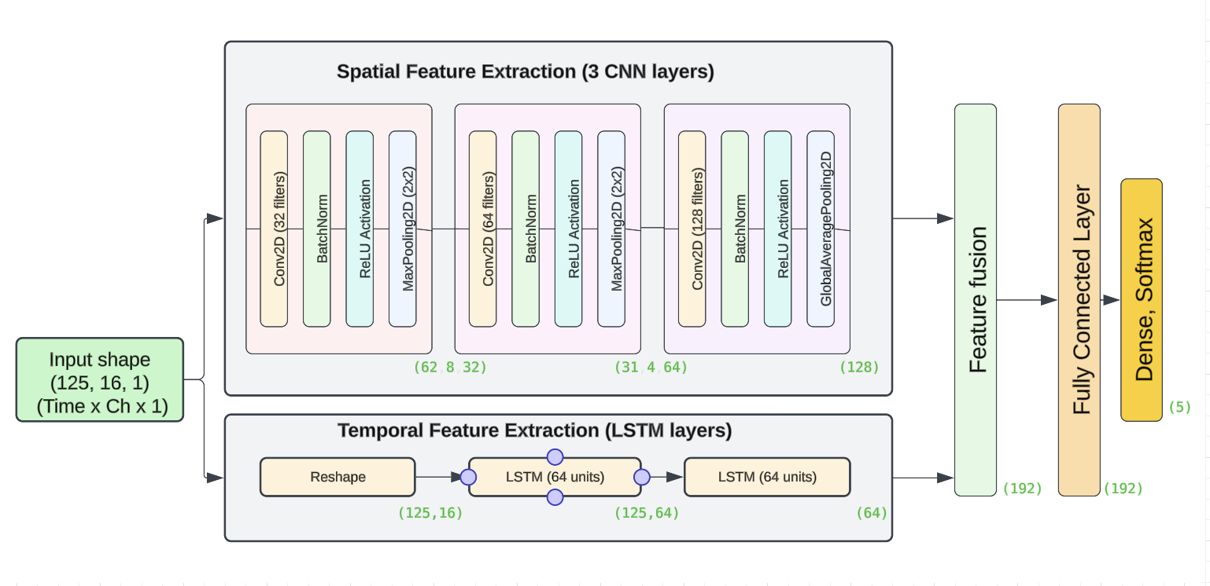  
**Spatial features - CNN:**

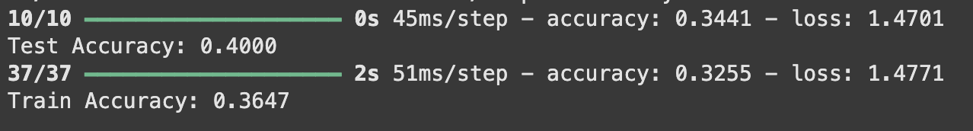

**Temporal features - LSTM:**

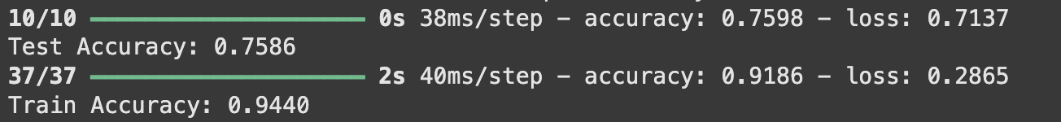

**Fused features - Spatio-Temporal FNet:**

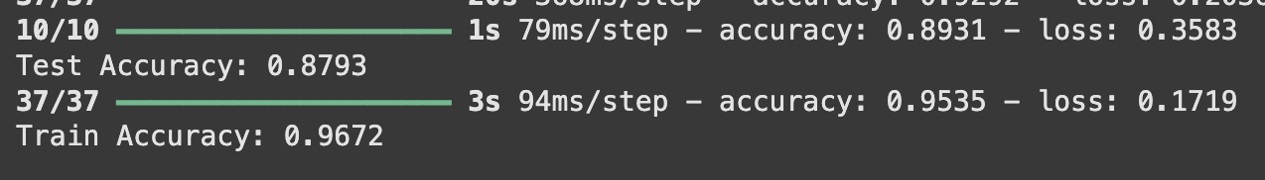

**Spatio-Temporal FNet:**

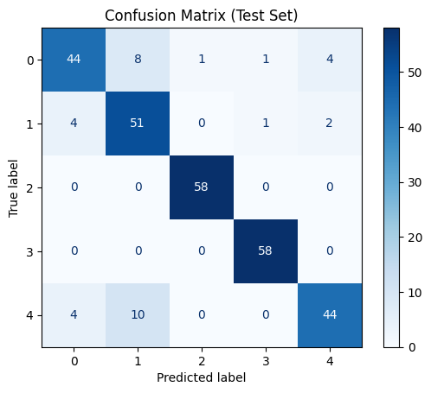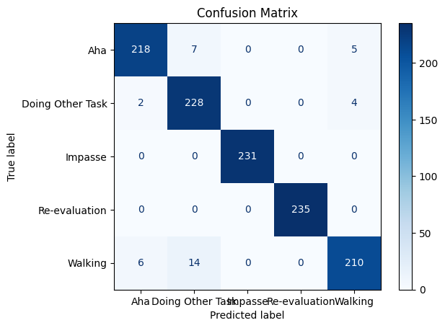

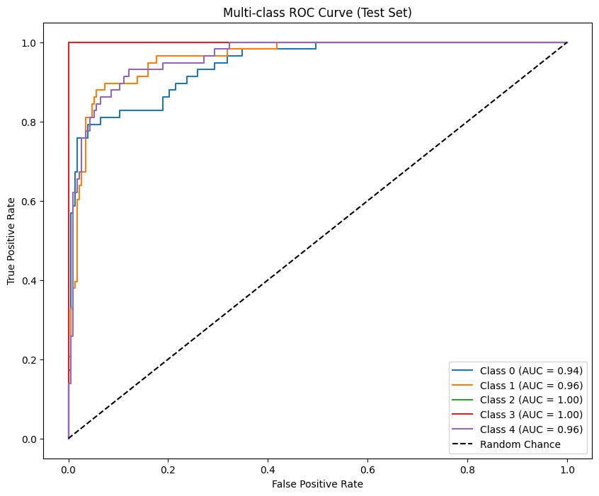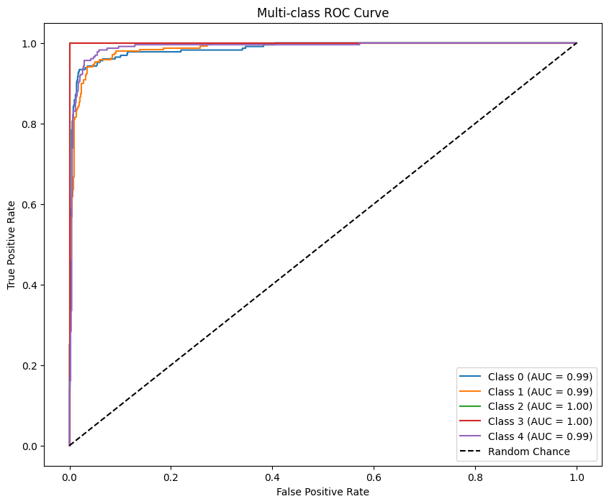

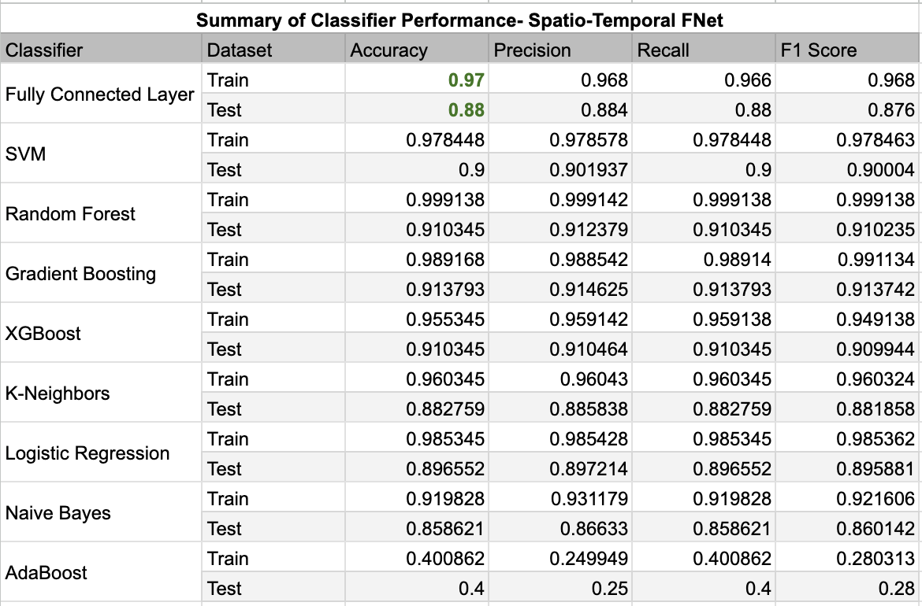



* **Add column - feature type - network embedded FNET, Summary features**

Todo:

1. Improve augmentation -
2. Improve labeling
3. Combine the tables
4. Get labels from Xiaoting - compare -

Section B time - 3s